36.11.12.23 Item Translations Maintenance

Via this function we translate descriptions to required language.

Item Number: enter already existing code
Language: US (might be NL/DUT later on in your domain)
+ Next
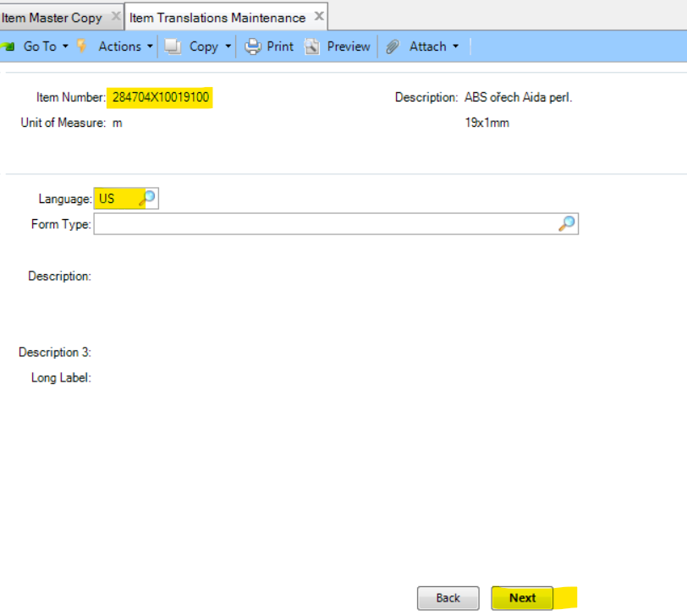

See next page.

Description: Ctrl+C of description in english (NL/DUT)
+ Next + 2x Back
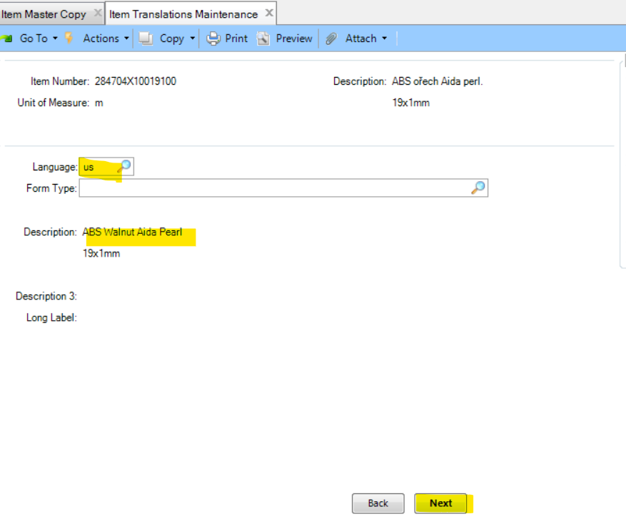

See next page.

Language: us (or NL/DUT) + Next
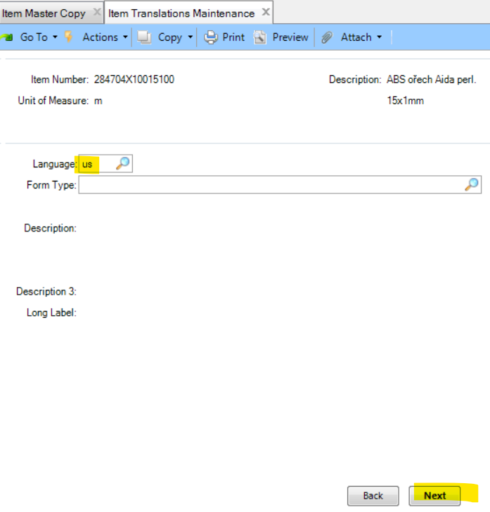

See nex page.

Description (1 line): Ctrl+V
Descritipon (2 line): write or copy correct dimension
+ Next
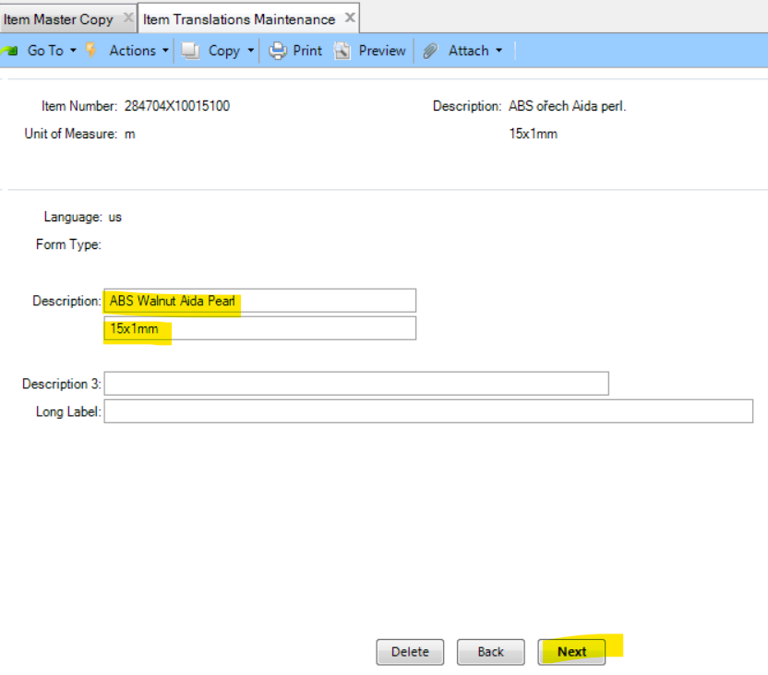

And thats it. After the article is maintained on HRX HQ, all branches can see it in their domains.

